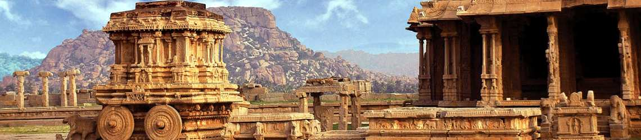

Sacred Stones, Prayerful Paths
A Journey into inspiring Karnataka, India
with Shubhraji
(4 to 16 February, 2020 12 nights/13 days)

4 Feb Arrival in Bengaluru - stay at Taj MG Road
5 Feb Puja in Bengaluru
6 Feb Drive to Chikmagalur - stay at Taj Chikmagalur
6-10 Feb Day visits to Belur, Halibedu, Sringeri Mutt (Monastery)
11 Feb Drive to Hampi - stay at a Luxury Resort
12-15 Feb Day visit to Aihole, Pattadakal, Badami
16 Feb Drive back to Bengaluru

HIGHLIGHTS:
Vedanta teachings with Shubhraji throughout the Trip.

